Example A – REVIEW ENGAGEMENT REPORT
Sample a)

Review Engagement Report

To the Members of <name of entity>
At the request of <name of entity>, we have reviewed the Schedules of Revenues and Expenditures for Child Care Services (and for Family Support Programs, if applicable) for the year ended March 31, 2017 (see note 1(b)). These schedules meet the financial reporting requirements specified by the Ministry of Education. Our review was made in accordance with Canadian generally accepted standards for review engagements and accordingly consisted primarily of enquiry, analytical procedures and discussions related to information supplied to us by the Council.
A review does not constitute an audit and consequently we do not express an audit opinion on this financial information.
Based on our review, nothing has come to our attention that causes us to believe that this financial information is not, in all material aspects, in accordance with the <name of entity>’s basis of accounting.
The schedule(s) of revenue and expenditures has/have been prepared solely for the information and use of the <name of entity> and the Ministry of Education for the stated purpose, and should not be used by anyone other than the specified users, or used for any other purpose.

Chartered Accountants
Licenced Public Accountants

Date

Sample b)

Schedule of Revenues and Expenditures – Child Care Services
Year ended March 31, 2017 (unaudited)

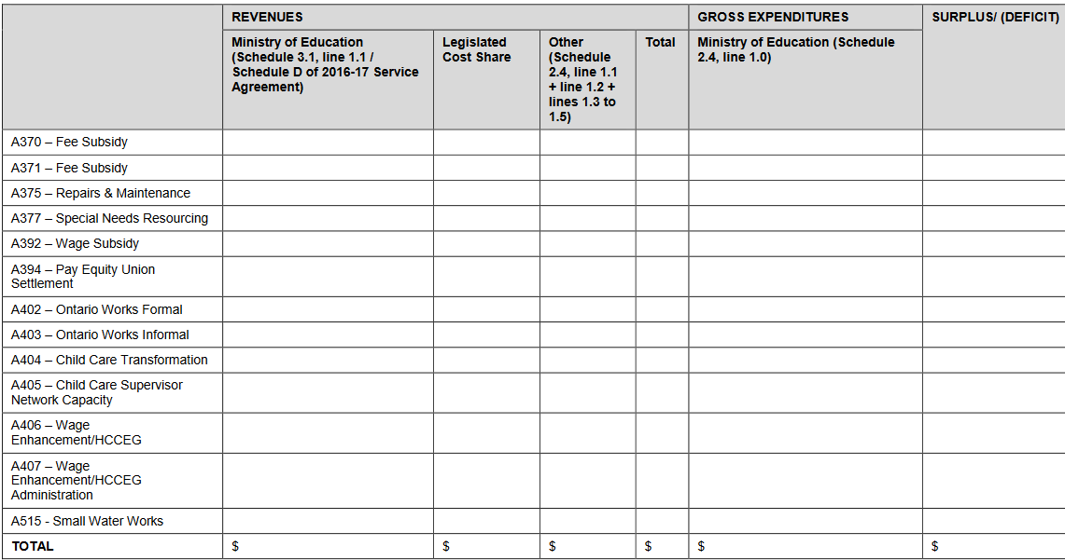

Sample c)
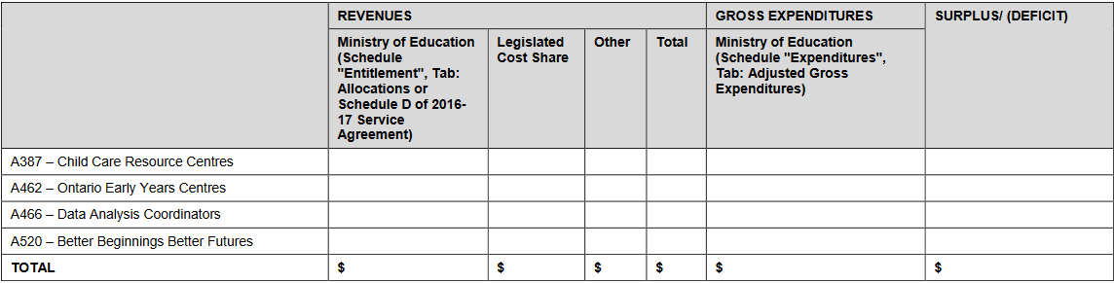

Sample d)

Notes Accompanying Schedule of Revenues & Expenditures – Child Care
Services and/or Family Support Programs
For the year ended March 31, 2017
(Unaudited)

The <name of First Nation/TPA> Child Care Services and/or Family Support Programs are programs funded by the Ministry of Education that aims to <insert purpose>

1. Significant Accounting Policies

(a) Revenue recognition
Revenue is recognized when it is determined to be receivable.

(b) Basis of Accounting
<Insert basis of accounting used>

Sample e)

Notes to the Financial Statements

Note <insert number>. CHILD CARE AND/OR FAMILY SUPPORT PROGRAMS SERVICE AGREEMENT WITH THE MINISTRY OF EDUCATION

<Insert name of First Nation/TPA> has a child care and/or family support program service agreement with the Ministry of Education. A requirement of the service agreement is the production of supplementary information by detail code/funding type, which summarizes all revenues and expenditures relating to the service agreement(s).

A review of these revenues and expenditures, by detail code/funding type, are outlined below. The identified surplus / (deficit) position is reflected prior to the application of flexibility in accordance with the Child Care Business Practices, Funding and Service Guideline.

<Insert a schedule of revenues and expenditures for Child Care and/or Family Support Programs from sample b) and/or c)>

These results comprise part of the <insert name of revenue category> and <insert name of expenditure category> that are included in the consolidated statement of operations.

